**Documentation**

*Chaotic Workers*

*May 17th 2022*

* ***.***

# Team members

* Hammad Karamat
* Ajoke
* Ajay Paul
* Kristina Bala

# Introduction

**What are “Internet of Things” and “Wireless Sensors Network” in your project domain about?**

The rise of the Internet of Things (IoT) has been attributed to the increasing number of devices and the global connectivity of the Internet. This has led to the development of new communication protocols that allow smart objects and machines to communicate with each other and with other people.

This paper focuses on the Wireless Sensor Network, which is the most commonly used network for monitoring and controlling smart home devices. It provides an overview of its various technical challenges and countermeasures.

The goal of this study is to provide a comprehensive view of the various aspects of the Internet of Things (IoT) and its various technologies. It also reviews the various visions of this new paradigm and provides a comprehensive analysis of the security and privacy risks associated with it.

# Concept description

*Block diagram of your target application. 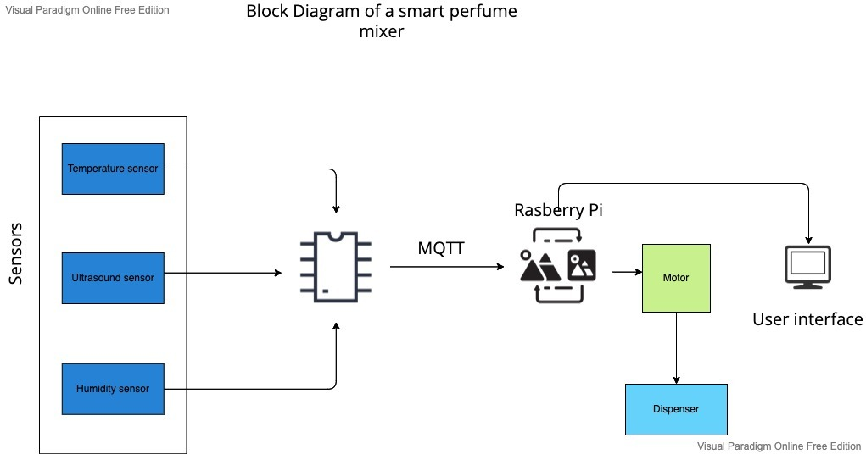*

*What is the main application for your prototype?*

Focus of our application is to provide control and/or provide autonomous use of air freshener/Perfumery devices. The device can be controlled remotely through a smartphone app or it can be chosen to be autonomous using the data contracted from the inbuilt.

A memory card stores fragrance recipes provided by the user and provide power and digital information to function the electronic components. This activates selected scent capsules and creates a programmed combination of scents to give a programmed fragrance, using a microcontroller to control the precision . It was hoped that the working prototype would generate interest leading to funding of a response.

The concept Developed from existing products on the market today that can recognise and replicate preprogrammed scents and ultimately it should lead to electronic scent detection and emission but the difference between our product is that it is manually controlled also and with the help of the Ultra sound detector it measure the depth for the room to provide data of how much fragrance would be required to intensify the scent in the room, it will help when taking costs and efficiency in to account.

sensors.

*Which devices, sensors, actuators, apps etc. are using for your application?*

# Project/Team management

*Which project methods you used in your project?*

*Breakdown: How you managed your tasks?*

*What are the different tasks/roles of the team members in the project?*

*Describe which team member did which tasks.*

# Technologies

# *Describe the technological approaches you will use to implement your project.*

* *Sensor technologies*

1. *Moisture sensor*
2. *Sound sensor*
3. *Motion sensor*
4. *Temperature and Humidity Combination Sensor*
5. *Ultrasonic Distance Sensor*
6. *Water Level Sensor (Leak Sensor)*

* *Communication protocols*
* *programming languages*

1. C++
2. HTML
3. CSS
4. Javascript(REST)

* *...*

# Implementation

*Describe the static structure of the environment.*

*Provide a class diagram for this purpose and briefly explain the classes or modules.*

*Describe the use case(s) of your environment*

# Use Case

*Give instructions on how to use your application. Potentially using an/more example(s), figures, screenshots etc.*

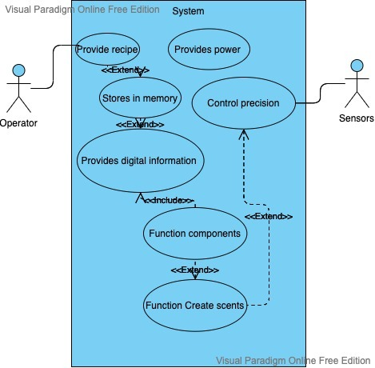

# Sources/References

*Provide the sources on the technologies and algorithms you used in your project (Github).*